Week beginning Monday 18th May: Years 5 and 6 Science
Did you enjoy the lesson on refraction last week? Remember that refraction is when light bends as it passes from one substance to another. Today we are going to carry on with our project on light, and we are going to do some more exciting activities.
Learning Objective
We use the term ‘white light’ to describe light from the sun and other light sources. We are going to learn that white light is made up of many colours, and that these can be separated out.
This is a glass prism. The white light enters and splits into its different colours.
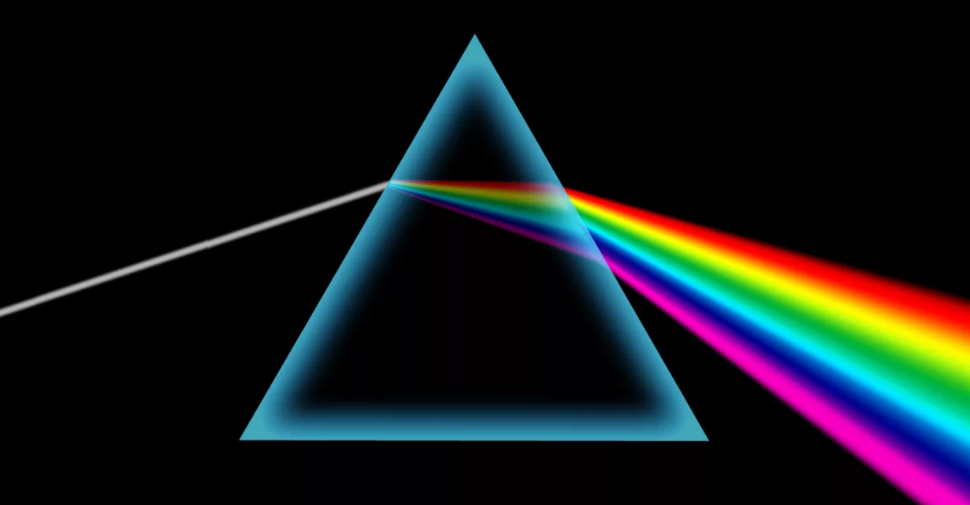
Activity 1: Where do colours come from?
First watch this clip from BBC Bitesize.
https://www.bbc.co.uk/bitesize/topics/zw982hv/articles/zcj73k7
White light is made up of the following colours: red, orange, yellow, green, blue, indigo, and violet. Each coloured light has its own wavelength. Red light has the longest wavelength and violet light has the shortest wavelength.
When white light shines towards a glass prism, it splits up into the different coloured wavelengths. Each wavelength slows down and changes direction. Red light changes direction least, and violet light changes direction most. The light leaving the prism is spread out into its different colours - a process called dispersion.
Activity 2: Rainbows

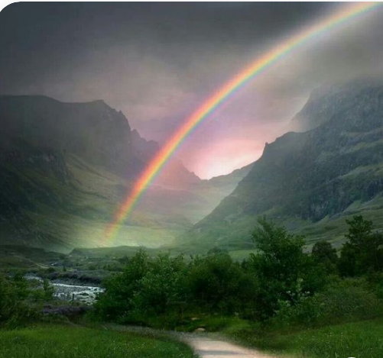

Watch this short clip about how a rainbow is made. Take notes as you watch.

https://www.youtube.com/watch?v=GqbgJ3c3yhc

Now watch this clip. You might need to watch it twice because it is quite tricky! Take notes as you watch.

https://www.youtube.com/watch?v=hY9GX2mpmnc

Write a summary of what you have learnt from these videos. Remember to include the colours of the spectrum (red, orange, yellow, green, blue, indigo and violet). Create your own mnemonics such as:

Richard Of York Gave Battle In Vain.

Activity 3: Making a colour wheel

First watch this short clip about how to make a colour wheel. (I prefer the second idea where you use a marble, but both wheels work well.)

https://www.youtube.com/watch?v=lil4co0z7QA

Now have a go at making your own colour wheel.

If you don’t have all the equipment that you need, please draw a beautiful rainbow.

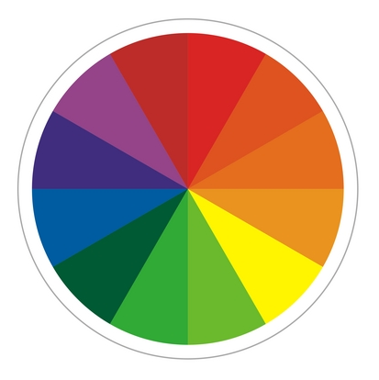

Extended learning

The next time it is sunny, and if you have access to a hosepipe, then you can create a real rainbow. Turn the hose on and cover the end so you get a fine spray. Stand with your back to the sun and spray the water as widely as possible to get fine mist. You should see a rainbow in the spray.

(Make sure you check with the people at home before you do this!)

