Topic Work Year 3 and 4 - Wednesday 6th May
Contours, Keys and Symbols - Map reading skills
https://www.bbc.co.uk/bitesize/articles/zvxwjhv
Watch this clip by following the link above  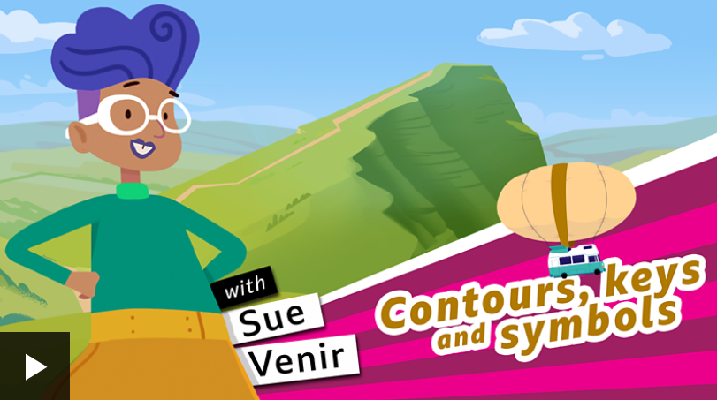 | Activity one  Play this game from the link above.  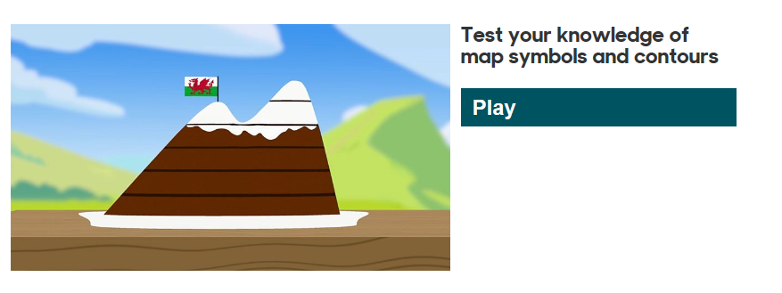
Activity 2  https://www.ordnancesurvey.co.uk/mapzone/  Follow the link to the Ordnance Survey learning site. These are the people who make maps of the United Kingdom. You can find learning clips, quizzes and games to play here. It is fun! | 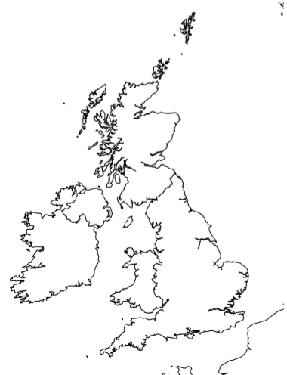  Activity 3  Here is a map of the UK. Can you locate and name the capital cities of the four countries that make up the UK?

