Science Year 3 and 4 Rocks, soil & fossils Wednesday 8th July 2020
https://www.bbc.co.uk/bitesize/articles/z6r6wnb
Watch the 4 clips by following the link above  Can you challenge yourself to think all the way back to our topic in the Autumn term, Adventurers and Explorers, when we looked at fossils and how the Earth was formed over millions of years? See how much you can remember!  1 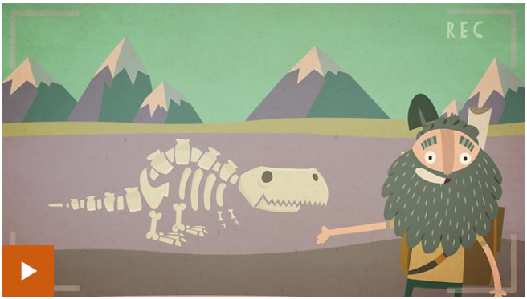 2 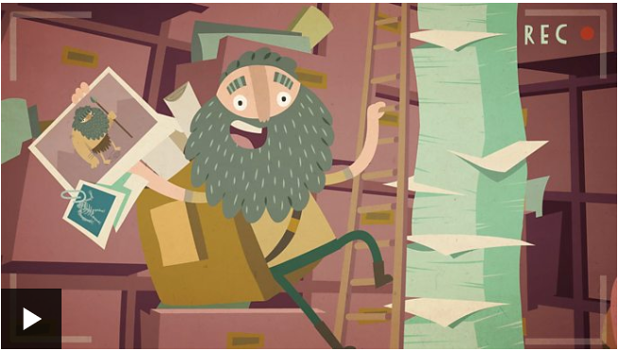  3 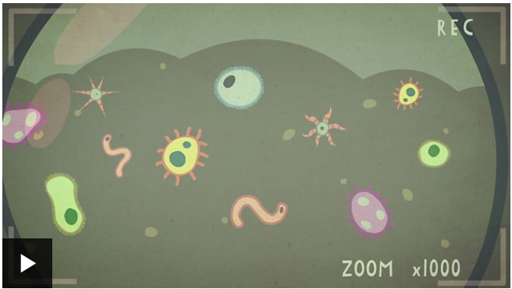 4 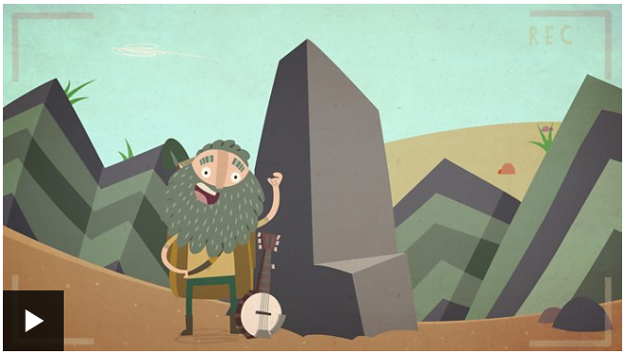 | Activity one  Test your knowledge of what you have remembered and learned so far with this quiz:  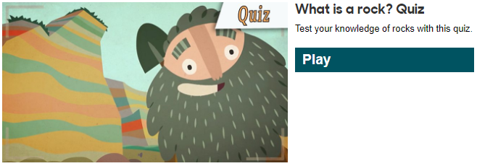
Activity Two  Now, challenge yourself further to fill in the blanks:  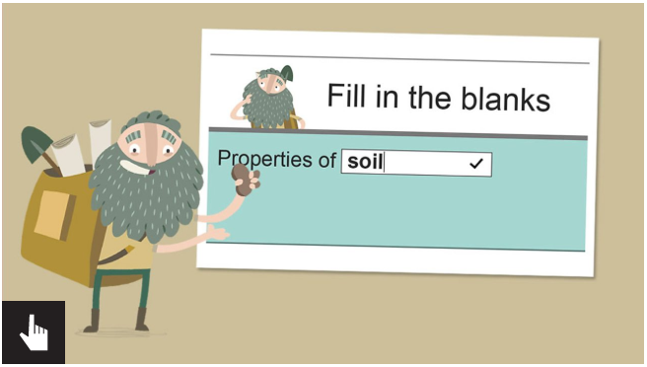 | Activity Three  Have a look at these two activities – a rocks wordsearch and a dinosaur / fossil matching game. Don’t worry if you can’t print these off, have a look on your device’s screen and see what you can match on there.  