Friday 3rd July
We are at the end of another week. I know that from next week, some of you are returning to school for the final two weeks of term. I will still be setting our Year 3 work like I have always done, so whether at school or home you can still achieve the Year 3 work expectations. I will call those children remaining at home, so if you have any questions about the work or next term – I will try my best to answer them for you.
English – Read the story and discuss the five questions with an adult. Remember you must give reasons for your answers.
King Midas and the Donkey’s Ears
Once upon a time, a long time ago, Pan, the god of shepherds, challenged Apollo to a musical duel. Pan insisted his flute of reeds could produce a more beautiful melody than Apollo's silly harp. The two agreed on a contest with judges. One of the judges was King Midas. After hearing the two melodies, all but one of the judges chose Apollo as the winner. But one judge, King Midas, preferred Pan's tune. Furious that anyone could prefer a reedy pipe to his musical lyre, Apollo cooed, "I see the problem. It's your ears. They are too small to hear properly. Let me fix that for you."
King Midas felt his ears quiver. His ears sprang out, and out, and turned into the large furry ears of a donkey. King Midas was horrified. He grabbed his ears. "Pan, help me!" he cried. But Pan, with a quick nervous glance at Apollo, turned his back. King Midas tried to hide his ears from his subjects by wearing a variety of huge hats, heavy helmets, and bulky scarves.
The only person who saw his ears was his barber. King Midas made his barber promise he would never tell a soul. His barber kept his word. But keeping such a huge secret to himself was driving him crazy. Finally, the barber went up a mountain and almost to the edge of a cliff. He dug a hole in the midst of some reeds. He looked about, to make sure no one was near. Then, he whispered into the hole, "King Midas has the ears of a donkey. The King has donkey ears! The King has donkey ears!" Having got his secret off his chest, he felt much better. He returned home, sure that he had kept his word. Unfortunately for King Midas, the barber had dug right into a piece of Echo. Echo was a wood nymph who could only repeat the last few sounds she heard. When she died, pieces of Echo were scattered all over the mountainous kingdom. In fact, pieces of Echo were scattered all over the world, repeating the sounds around her. Although I suppose some people might think it was only the sound of the wind in the reeds, it was really a piece of Echo, whispering over and over, "The King has donkey ears, the King has donkey ears." Sound travels well in the mountains, even whispers. It was not long before the entire kingdom knew King Midas' secret.
1. How did Midas anger Apollo?
2. Do you think Apollo was fair? Why or why not?
3. How do you think King Midas felt when he noticed the change?
4. Why do you think King Midas tried to hide his ears?
5. Why was it hard for the barber to keep the secret?

Maths
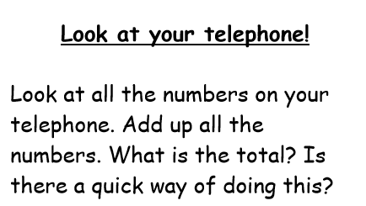

1)

2) Play Hit the Button https://www.topmarks.co.uk/maths-games/hit-the-button choose doubles and halves to start with, then try times-tables. Good luck.

Other activities:

- Play TTRS
- Practice counting in 2s, 10s, 50s, 100s
- Lesson from BBC Bitesize on Sculptures https://www.bbc.co.uk/bitesize/articles/z9ggp4j

Well done.
Mrs C Flynn

