Week beginning Monday 15th June
Years 5 and 6 History
We have now finished our short project about King Henry VIII. This week, we are going to learn about the Anglo Saxons.
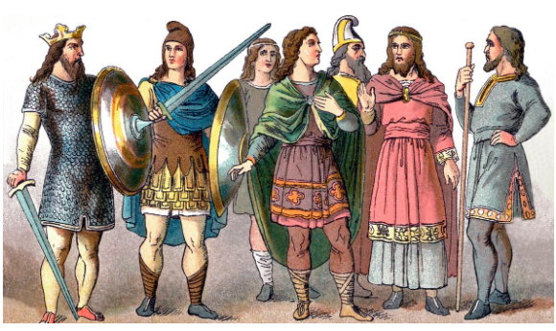

- Please go to BBC Bitesize and find the history lesson for 1st June: Who were the Anglo Saxons? You can find this lesson here:
https://www.bbc.co.uk/bitesize/articles/z4bkjp3
- Watch the first video to learn more about the Anglo-Saxons and how they lived.
- Please read the information underneath this clip really carefully.
- Explore the village in the picture and listen to Hild as she tells you about her life, friends, and family. Read the information underneath carefully.
- Now watch the third clip to find out more about the life of the Anglo Saxons.
Activities
Now have a go at these activities.

Activity 1: Make a piece of artwork showing an Anglo-Saxon village. This could be a poster or even a 3D model village.

Activity 2: Watch this tour of an Anglo-Saxon village. Can you add anything to your creation from activity 1?
Activity 3: Use these comprehension sheets to find out more about two famous Anglo-Saxon kings: King Alfred and King Athelstan.