EYFS Topic Home Learning
Topic: Amazing Animals & Minibeasts
We will learn about: |  | To identify and learn about different types of bugs.
Words we can use: |  | Caterpillar, butterfly, dung beetle, insect, habitat, worm, bee, fly, wasp, ant, woodlice, ladybird, cricket, spider.
Questions we can ask: |  | Where do bugs live? What do they eat? What do they need to stay safe?
Activity: |  | Bug Hunt: How many different bugs can you find in your garden or out on a walk?
Stories: | The Very Busy Spider by Eric Carle  https://www.youtube.com/watch?v=TfL0g-XRxnA  The Bad-Tempered Ladybird  https://www.youtube.com/watch?v=bH6UIYCRmAE
Things you could do:
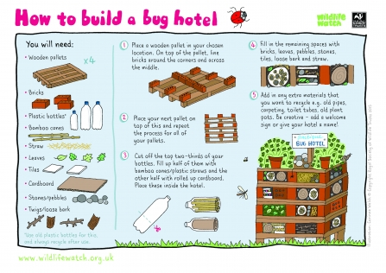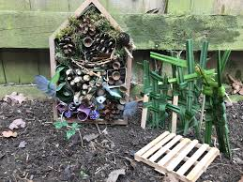

Watch what bugs do

Dung Beetles
https://www.youtube.com/watch?v=Zskz-iZcVyY

Crickets
https://www.youtube.com/watch?v=9cbZmOvRySk

Spiders
https://www.youtube.com/watch?v=UDtlvZGmHYk

