Topic Work Year 3 and 4 - Wednesday 20th May - Longitude and Latitude
https://www.bbc.co.uk/bitesize/articles/zr7j7nb
Watch this clip by following the link above  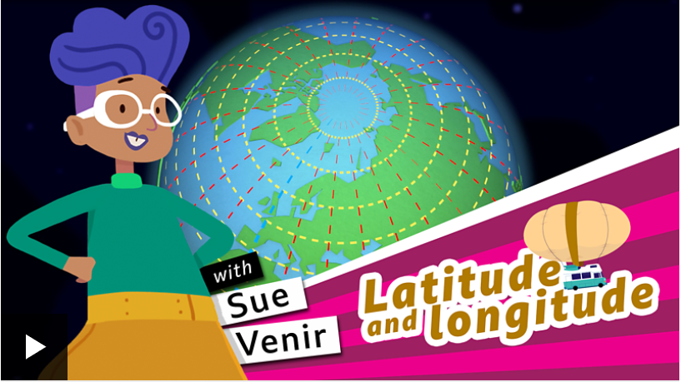 | Activity one  Play this quiz from the link above.  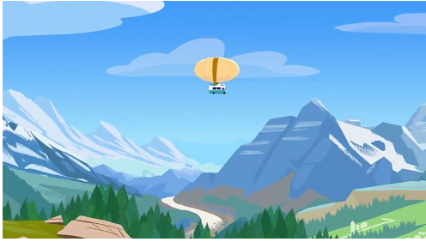
Activity 2  A wordsearch with key Geography words is on the separate page. Do not worry if you can not print it off, hopefully you can do it on screen. Challenge yourself – can you find all the words in 5 minutes? | Activity 3  https://www.bbc.co.uk/teach/class-clips-video/geography-ks2-in-my-shoes/zn7wpg8  If you follow the link about, you will see many clips of children from all over the world. They are telling you about their lives and what it is like to be ‘in their shoes.’ Watch some clips and compare their lives to ours. Are we lucky compared to others around the world?

