Week beginning Monday 18th May: Years 5 and 6 History
History and Geography
We are going to continue with our short project about the Ancient Egyptians.
- Please go to BBC Bitesize and find the History lesson for 4th May: What did the ancient Egyptians believe in? You can find this lesson here:
https://www.bbc.co.uk/bitesize/articles/zdq3wx
- Watch the first clip and then join in with the song!
- Please read the information underneath this really carefully.
Activities
Now have a go at these activities.
Activity 1: Can you name the ancient Egyptian gods?
Try to match each ancient Egyptian god with their picture.

Activity 2: Ancient Egyptian word search.
How many words about the Ancient Egyptians can you find?
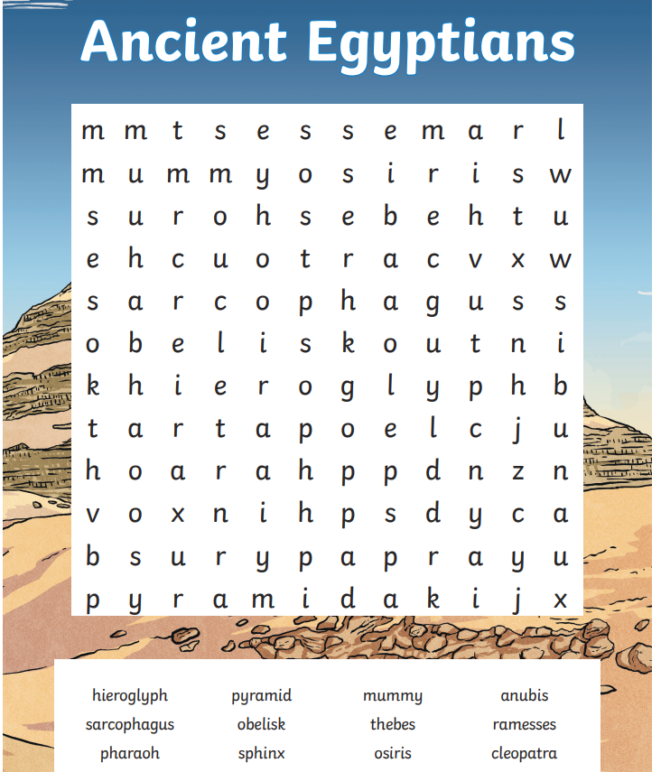

Activity 3: Sequencing and retelling.
Read this story about the ancient Egyptian god Osiris.
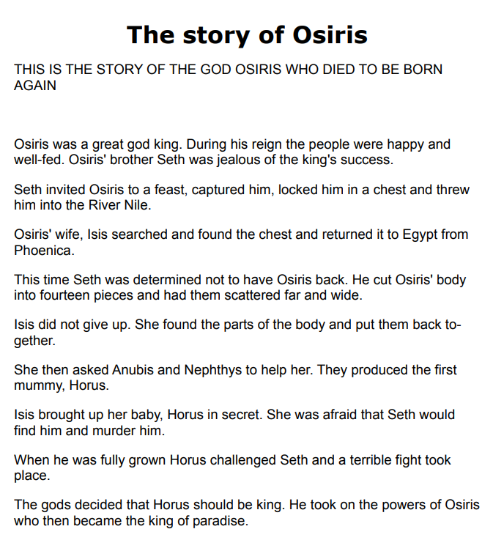
Now look at the information on the following page. Without looking back, can you put it in the correct order?
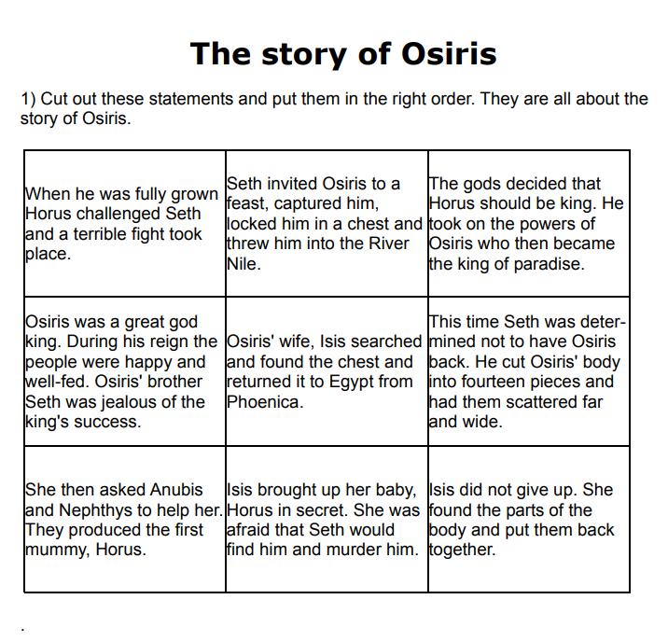
Now rewrite the story in your home learning book in your own words.

