Science Year 3 and 4 Introduction to States of Matter Wednesday 6th May 2020
https://www.bbc.co.uk/bitesize/articles/zvxthbk
Watch these three clips by following the link above  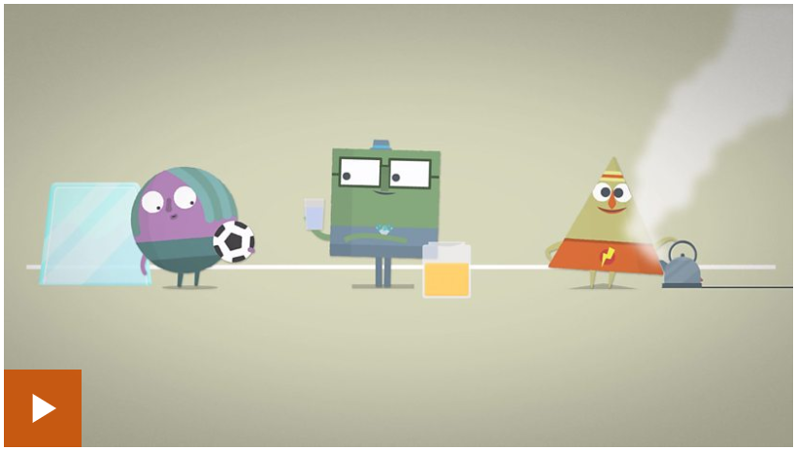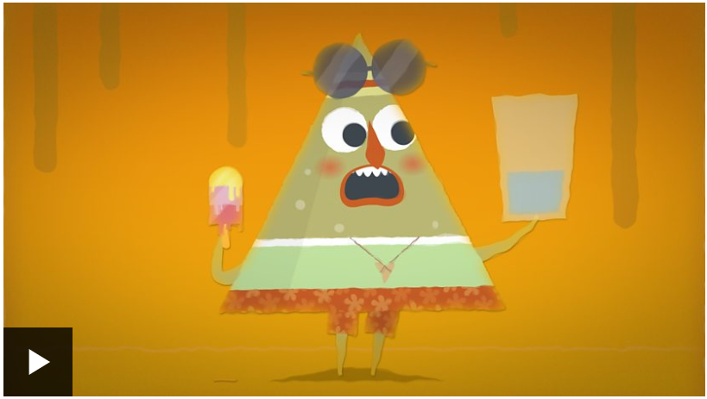  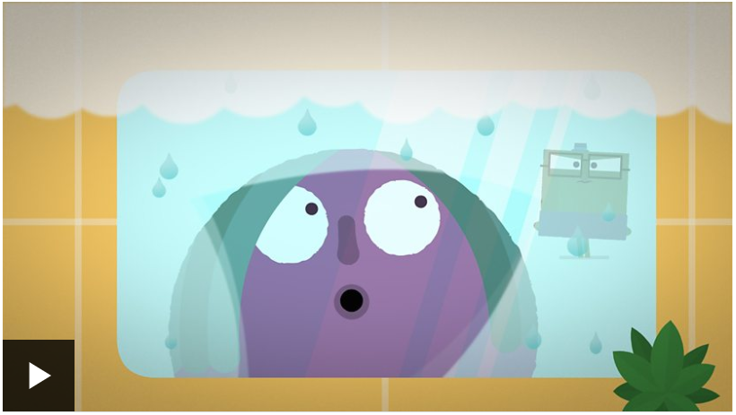 | Activity one  Test how much you’ve learned and remembered by playing this sorting game from the link above.  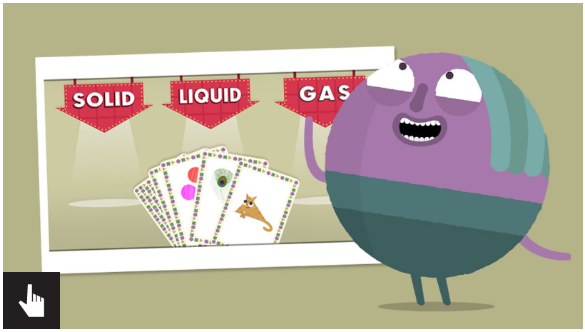
Activity 2  Activity 2 – ADULT SUPERVISION REQUIRED  Pour some water into an ice cube tray and leave it in the freezer for a couple of hours. Show your children how the water has changed from a liquid (water) to a solid (ice) when it has been cooled down.  Ask your children what they think might happen if they leave the ice cubes out in the air. Come back after a while and test their predictions.  Finally, put some water in a pan and bring it to the boil. Show your children that heating up a liquid will change it into a gas (steam). | Activity 3  Can you have a look around your house and see how many different things you could classify as a solid, liquid or gas? How about if you look out of your window, or go for a walk? What can you spot then? Challenge your family to do the same, and remember these rules:  