Science Year 3 and 4 What Plants Need to Live Wednesday 13th May 2020
https://www.bbc.co.uk/bitesize/articles/z6m4kmn
Watch these three clips by following the link above  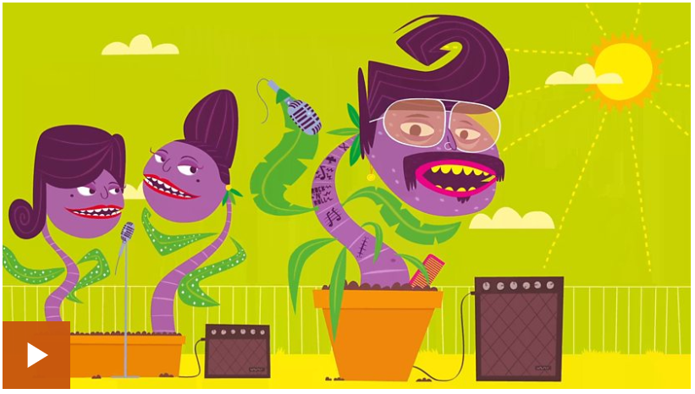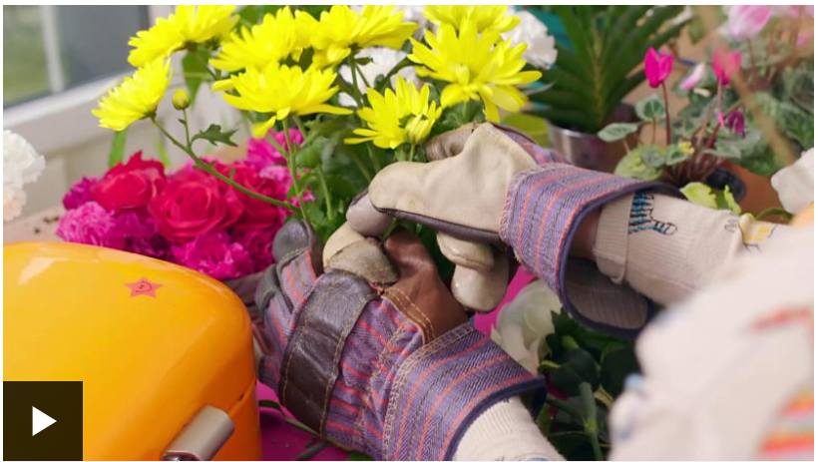  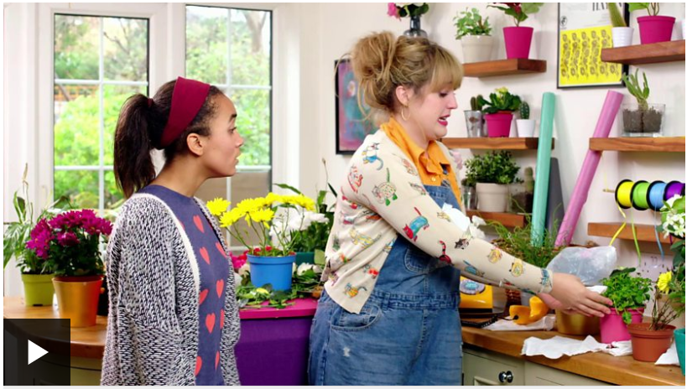 | Activity one  Test how much you’ve learned and remembered by playing the ‘fill in the gaps’ game:  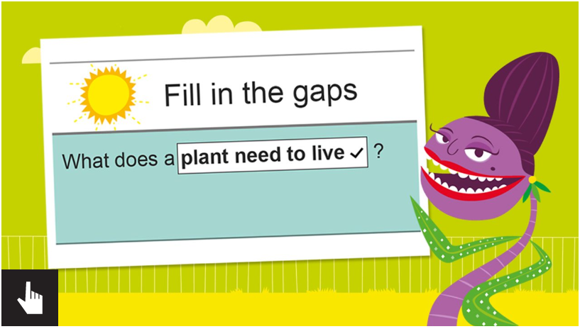
Activity 2  Activity 2 – ADULT SUPERVISION REQUIRED  Have a go at completing the Poorly Plant activity. There is a link on the website, but we have also downloaded the sheet for you as well. You can plan your investigation in your blue books.  Challenge yourself – can you use these scientific words:  Light dark water grow die plant measure | Activity 3  Have a look around your house, are there any Poorly Plants there? Could you help your adults by putting your planned investigation into actual practise?  If you have any house plants maybe ask your adults if you could be in charge of looking after them for a week – or longer if you fancy? Can you check on them each day, make sure they get lots of sunlight and fresh air, and that they are watered carefully – not too little and not too much! If you’re really successful, maybe your house plant might start to flower. Can you send in a photo of your house plant showing how well you care for it?  