Wednesday 22nd April, Year 5

English
Vocabulary session:
Find out what each of these words mean and use them in an exciting sentence, demonstrating you understand the meaning of the word.
briny | breeches | magenta | salary
galleon | shepherd | velvet | develop
portrait | gravel | embers | livid

Maths
Today we are going to investigate cubed numbers.
A cubed number is made when we multiply a number by itself twice.
For example, 2ᶟ is the same as 2 x 2 x 2 (= 8)
Choose your chilli challenge. When you have finished, check your answers on a calculator – NO CHEATING!
Calculate….  2ᶟ  3ᶟ  4ᶟ  5ᶟ  6ᶟ  7ᶟ | 2ᶟ + 3ᶟ  3ᶟ + 4ᶟ  5ᶟ + 4ᶟ  6ᶟ + 4ᶟ  7ᶟ + 6ᶟ  8ᶟ + 7ᶟ

Now try this challenge:
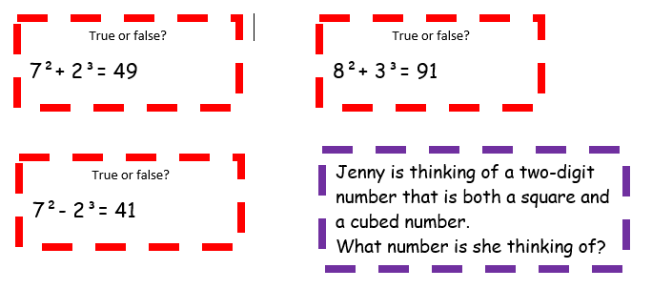
Extras
Don’t forget to read!
Practise your times tables – look at https://www.timestables.co.uk/games/ and create a free account.
Log onto NumBots and Times Table Rock Stars.

