Science Year 3 and 4 Food Chains Wednesday 10th June 2020
https://www.bbc.co.uk/bitesize/articles/zhnny9q
Watch the clip by following the link above  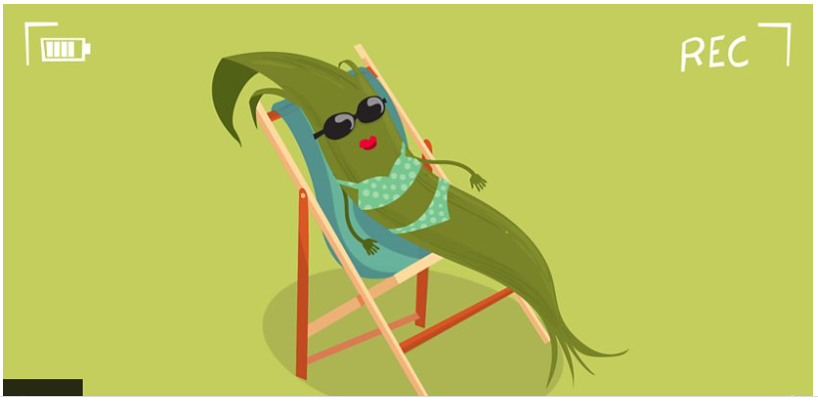  Now read the information about food chains that follows the clip on the BBC website. | Activity one  Have fun building your own food chains in the 3 interactive food chain challenges!  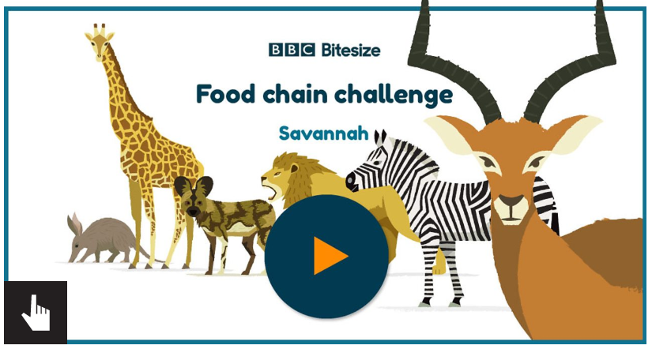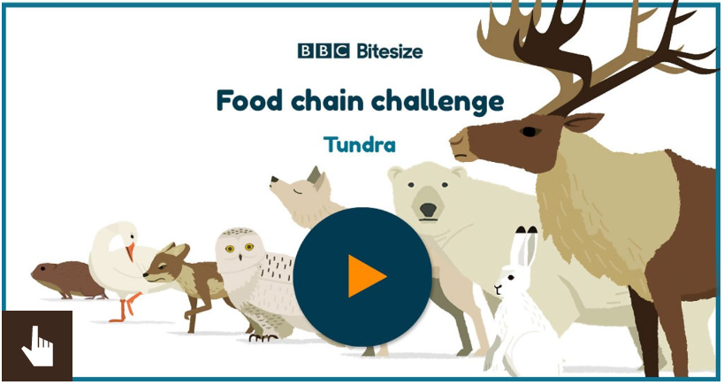  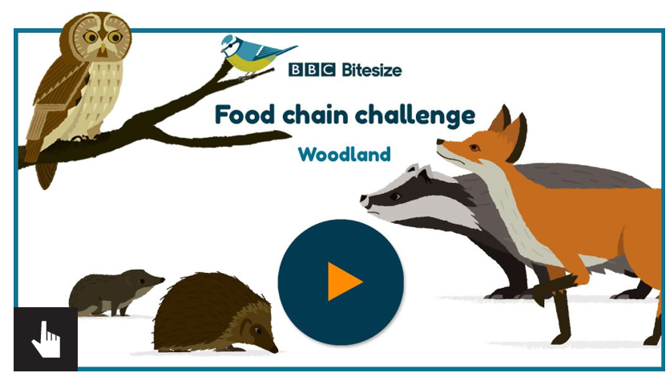
Activity Two  Test out your knowledge by putting the food chains in the correct order, and taking the online quiz:  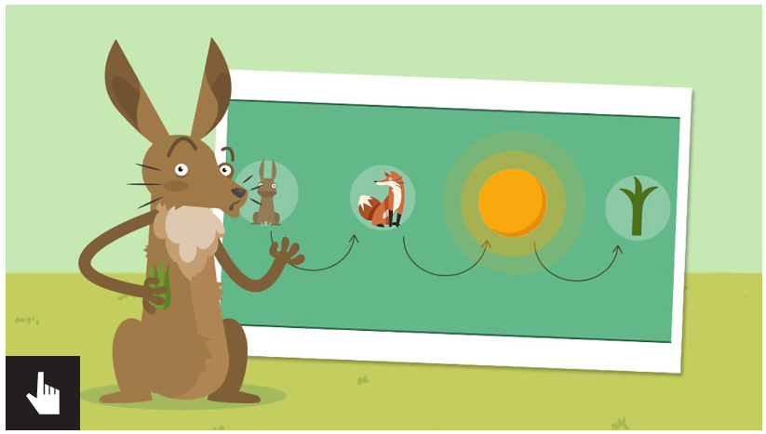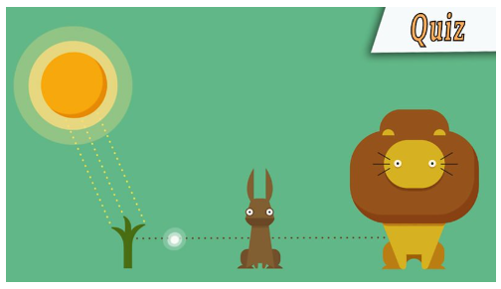 | Activity Three Predator Top Trumps Game  Make or print out your own predator top trumps! There are 20 cards on the Predator Top Trump pdf that you could print and cut out, or if you can’t print, make your own set with paper and pencils. Use the top trump cards to give you ideas, then research different animals yourself to add some of your own!  Have a game with your family – who will win, and how many facts can you remember from the cards?  Which predator is top of the food chain?  