Science Year 3 and 4 Wednesday 29th April
Introduction to Light and Dark
https://www.bbc.co.uk/bitesize/articles/zr8thbk
Watch these two clips by following the link above  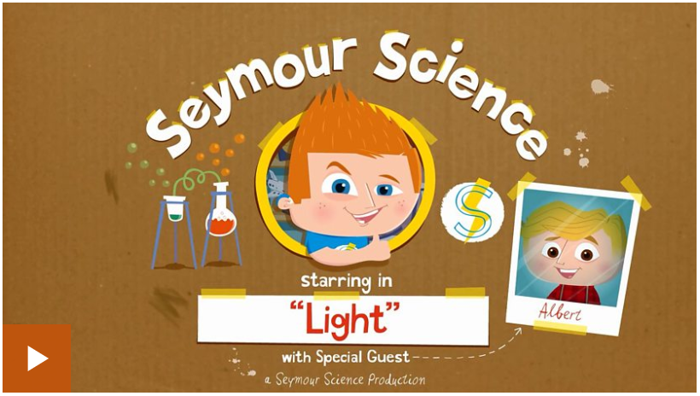  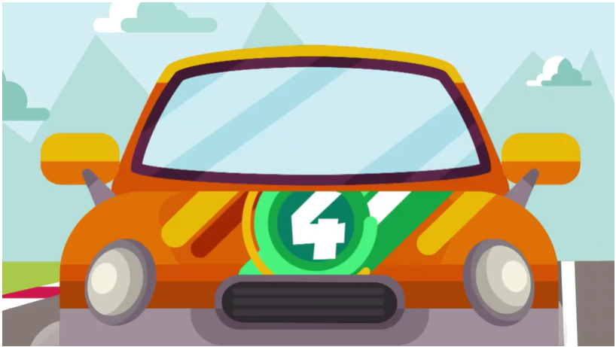 | Activity one  Test how much you’ve learned and remembered by playing this game from the link above.  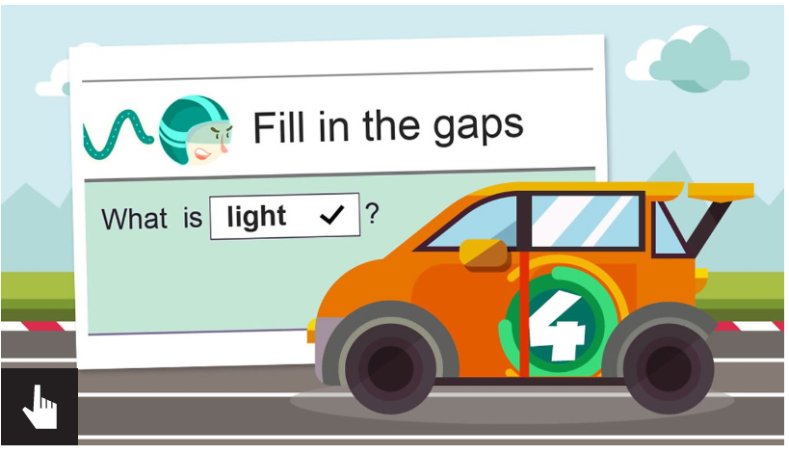
Activity 2  Choose a room in your house and see how many light sources you can spot in that room – you may be surprised how many there actually are! Remember, a light source is something that produces light, so you will need to think about electrical objects as well as the main natural source of light. Make a list, then challenge your family members to name them – do you think they’ll get them all? | Activity 3  Can you create a poster to explain these scientific words:  Light source transparent opaque shadow reflect  Challenge yourself to give a really scientific explanation of each of those words, along with drawing a picture of each to illustrate what you mean.

