Week beginning Monday 29th June
Years 5 and 6 History
This week we are going to start a short project about the Vikings. We are going to learn about the Vikings and their life in Britain.
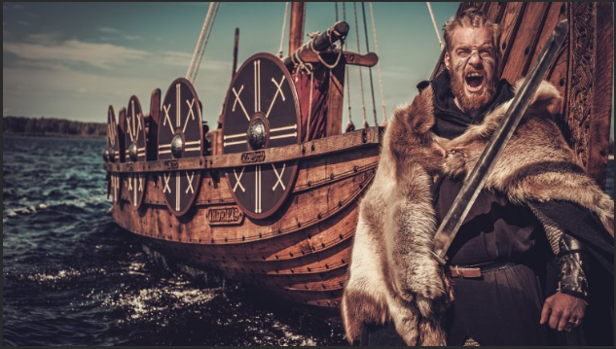

- Please go to BBC Bitesize and find the history lesson for 15th June: Who were the Vikings? You can find this lesson here:
https://www.bbc.co.uk/bitesize/articles/zsggp4j
- Watch the first clip to find out who the Vikings were.
- Please read the information underneath this clip really carefully.
- Now watch the second clip to find out about a Viking attack on the monastery at Lindisfarne.
- Read the information underneath carefully.
Activities
Now have a go at these activities.
Activity 1: Based on what you have learnt about the Vikings, create your own quiz for your friend or someone at home.
Activity 2: Design your own Viking longboat.
The image below shows one, but you can also search online for creative inspiration.

