Week beginning Monday 13th July: Years 5 and 6 Science
Last week we learned about the life and work of Marie Maynard Daly. This week we are going to learn about Alexander Fleming. First, please have a look at this information about Fleming.
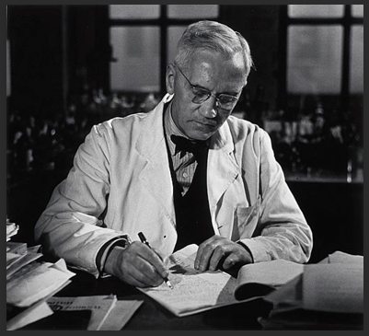
Here are some facts about Alexander Fleming.
- Alexander Fleming was born in Lochfield, Ayrshire (Scotland) on 6th August 1881.
- When he was twenty, Alexander started a course at St Mary’s Hospital Medical School in Paddington, London.
- His brother, Tom, was also a doctor.
- After completing his medical degree, Fleming joined the research team at St Mary’s. He was the assistant to Sir Almroth Wright, a bacteriologist.
- During World War 1, Alexander Fleming served as a captain in the Royal Medical Corps, working in the battlefield hospitals in France.
- In France, Fleming had witnessed large numbers of soldiers dying from infected wounds. He realised that the antiseptics being used destroyed the patient’s immune system and didn’t effectively stop the invading bacteria. He set about trying to find anti-bacterial agents.
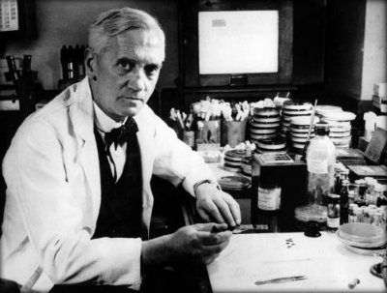
- Alexander Fleming discovered penicillin, the world’s first antibiotic (bacteria killer) by accident on 28th September 1928. He had left his petri dishes stacked up in his laboratory during his holidays and returned to discover the presence of a bacteria-destroying mould (penicillin).
- Fleming capitalised on his stroke of luck by thoroughly testing penicillin. He discovered that it would affect many types of bacteria, such as the ones responsible for scarlet fever, meningitis and diphtheria.
- Fleming published his research on penicillin and the scientists Howard Florey and Ernst Boris Chain built on Fleming’s findings and used them to mass- produce penicillin in order to treat the wounded soldiers of World War 2.
- Penicillin has saved the lives of millions of people.
- Fleming was knighted in 1944, becoming Sir Alexander Fleming.
- In 1945, Fleming, Florey and Chain were awarded the Nobel Prize.
- Alexander Fleming died in 1955. He had a heart attack. He is buried in St Paul’s Cathedral.
Activities
Now try out your Science skills with these activities. Have a go at activity 1. Please stick or draw out the graph in your book.
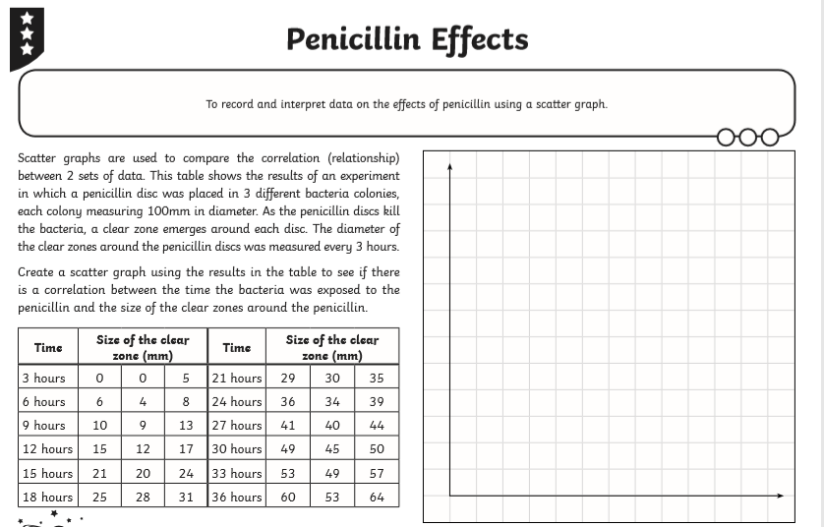

Now try activity 2. Can you draw and complete this activity sheet in your book?
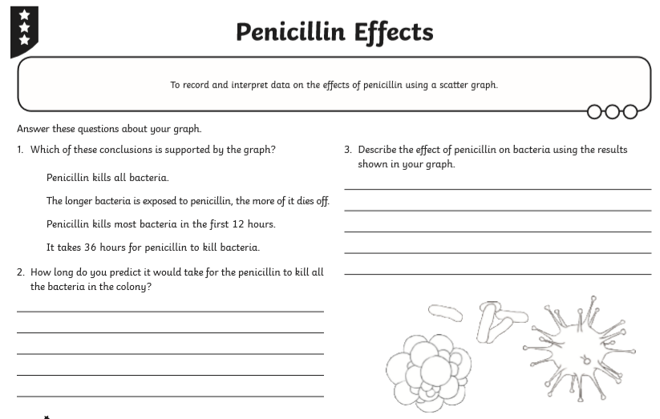

Activity 3 is to complete the activity sheet below in your book.

Alexander Fleming and Penicillin

Using the information below, make a timeline on the chart opposite, to show the major events in Alexander Fleming’s life.
In 1881 Alexander Fleming was born to a farming family in Scotland. In 1894 he moved to London and later trained as a doctor. He qualified in 1906 and began to research at St. Mary’s Medical School.
In 1928, he discovered penicillin. While studying influenza, he noticed that mould had accidentally developed on a set of agar plates he was using to grow the staphylococci germ. The mould had created a bacteria free ring around it. The mould broke down the cell walls of the bacteria and stopped it from reproducing. In 1928 he was elected professor at the medical school. He died on 11th March 1955.
1881
1. How did Alexander Fleming discover penicillin?

2. How does penicillin work?

3. What is it used to treat?
1951

