Thursday 9th July

English
How many ‘baddies’ can you name from all the stories you have read? Let’s see… there’s Mrs Trunchbull from Matilda, Cruella De Ville from 101 Dalmatians, Burt from Ratburger by David Walliams, ‘He Who Shall Not Be Named’ from Harry Potter, Captain Hook in Peter Pan…there are so many. Today I would like you to create a Wanted Poster for a ‘Baddie’ from a story you know well. You need to describe this character: what do they look like? Why are they wanted? Is there a reward? Who are they and where are they from?
You can draw a picture and write underneath or around the edge. You decide what your poster should look like. Here are some ideas to get you started. Remember you can send me a picture of your finished one. I would love to see them.
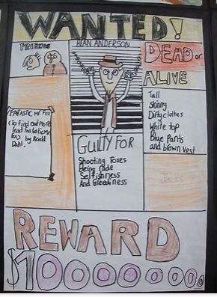
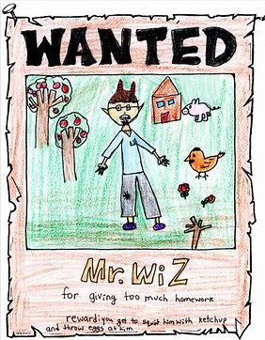
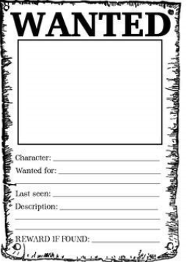

Maths
Pirate Maths. Separately, you should have been sent the maths work for today. It is one of the code breaking packs we have done before in class. You do not need to print anything; you can find the letters and then write them down on some paper to find out the correct code. When you think you have cracked the code – you can check it against the answers that are also enclosed. Good luck!

Other activities
- Art Week activity
- Science / Topic work
Well done
Mrs C Flynn

