Topic Work Year 3 and 4 - Wednesday 10th June - Weather and Climate
https://www.bbc.co.uk/bitesize/articles/z4xdqp3
Watch this clip by following the link above  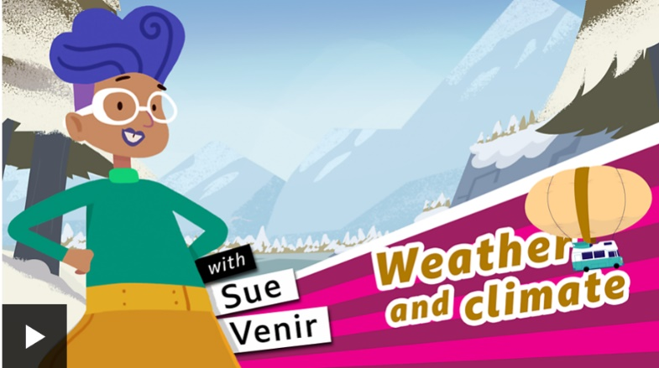 | Activity one  Play this quiz from the link above.  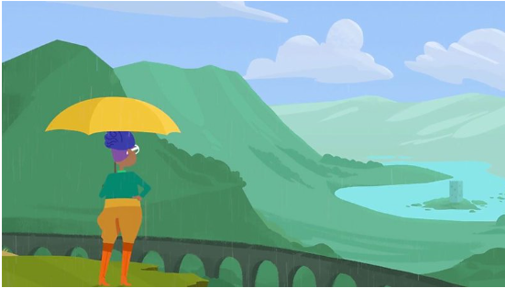
Activity Two – is a word search on the next page. | Activity Three  https://www.bbc.co.uk/newsround/49712457  Watch this clip about climate change. What does climate change mean? Is it important? Can we do anything to stop it?  CHALLENGE  Can you make a poster that you could put up in your window to help raise awareness and support for stopping climate change, suggesting things to do and ways in which we could be more environmentally friendly?  (HINT: how has lockdown already possibly helped climate change?)

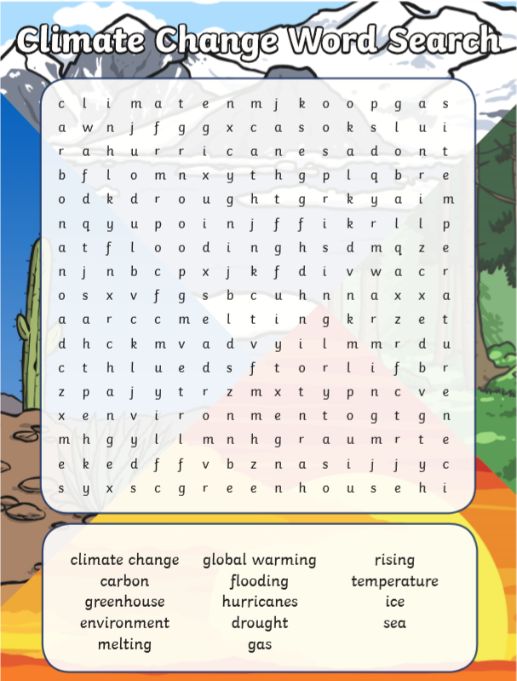
Activity Two

