Week beginning Monday 11th May: Years 5 and 6 History
Here are the answers to last week’s Egyptian comprehension.
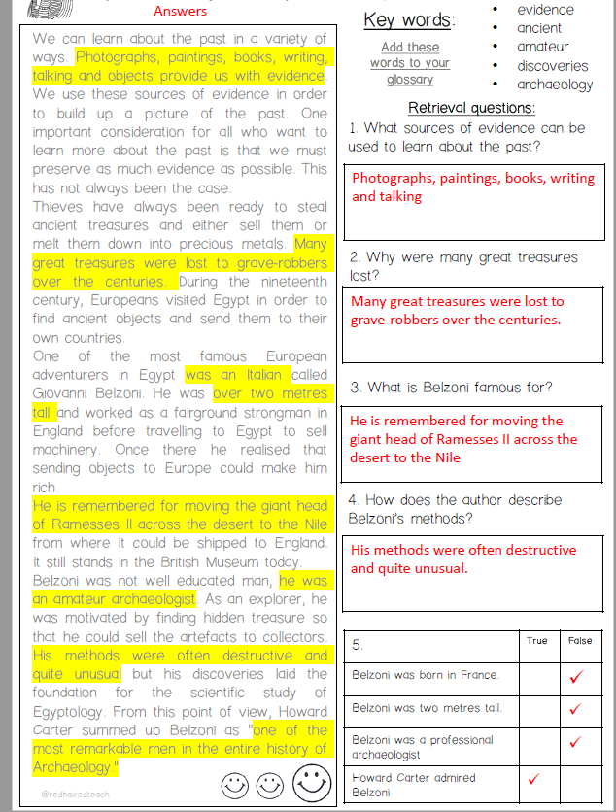
History and Geography
We are going to continue with our short project about the Ancient Egyptians.
- Please go to BBC Bitesize and find the History lesson for 27th April: What was life like for the Ancient Egyptians? You can find this lesson here:
https://www.bbc.co.uk/bitesize/articles/zbp6t39
- Watch the first clip and please read the information underneath it really carefully.
- Next, click the labels to find out what life was like in Ancient Egypt.
- Watch the last clip about what life was like for the Ancient Egyptians.
Activities
Now have a go at these activities.
- Activity 1: Create a poster about ancient Egyptian life. Use crayons, pencils or felt tips to present and draw what you have learned. You could include jobs, houses, food or anything from your own knowledge about ancient Egypt.
- Activity 2: Which foods would you find in Ancient Egypt? In this activity, sort some of the foods you would have found in Ancient Egypt. If you get stuck, read back through the lesson.
- Activity 3: Make your own Egyptian flatbread. With permission and supervision from an adult, you might like to try following this ancient Egyptian flatbread recipe and baking together!

