Optional Mini-Project 2: The Famous Person I Most Admire.
Lots of people admire Banksy, but who is he? Banksy is a British street and graffiti artist. He likes to remain anonymous and not let people know his true identity. He often draws in high visibility public places such as on buildings or train stations. His paintings are often about politics, war and other important topics. In his latest painting, which has just appeared at Southampton General Hospital, he shows his admiration for NHS workers.
It shows a young boy kneeling by a wastepaper basket. He has put his Spiderman and Batman model figures in the bin. His new favourite action hero is an NHS nurse.
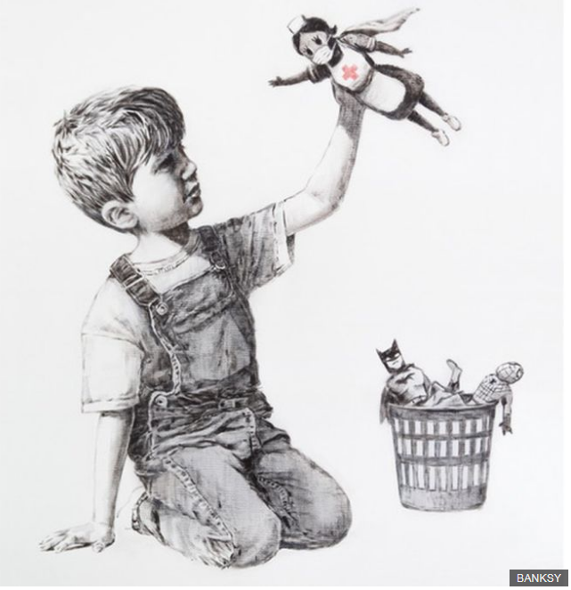

A YouGov poll found that, in 2019, these were the top 20 most admired people in the U.K. I was quite surprised by some of them!
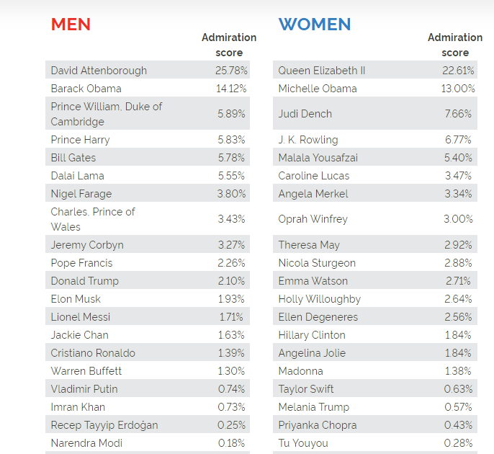
Your new project is about the famous person you most admire.
Some of my favourites include Florence Nightingale, Nelson Mandela, Beyoncé, Ernest Shackleton, The Queen, Abraham Lincoln and Michelle Obama.
But who do you admire? You could ask the people in your family to help you choose. Have a look at www.ducksters.com > biography for ideas.
Please include the following sections: key biographical facts about their life; the reasons you admire them; what we can learn from them.
Remember to include a cover and contents page, and any other sections which you feel are interesting about your famous person. You can do your project at the back of your home learning book or present it in another way that you think might be effective. When you have finished, please email a photo of it to the office. I would love to see it! Some of you have sent photos of amazing country projects!

