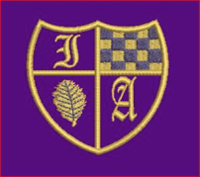 Project Learning at Home

Title: Our Wonderful World
Who is this learning for? | LKS2 Year 3 and 4
What will you learn? | You will learn about the oceans of the world.
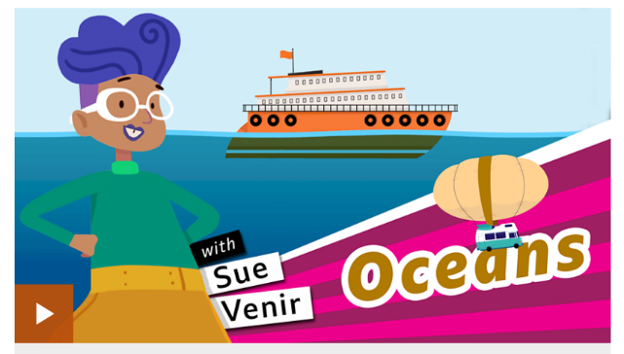
Click here to use this resource or do your own research using books and the internet. Watch the two videos on this link.

Here are some things you could try...
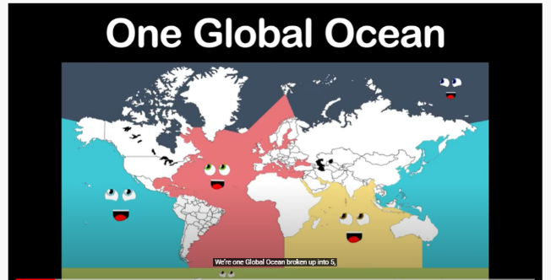  Here is a song to help you remember the name of the oceans. Once you have watched it, see if you can name them all. Click on the picture. | The oceans are home to amazing creatures. There are 228, 450 known species in the ocean an as many as 2 million that remain a mystery to us. The oceans are made of layers, where the different creatures live.  See if you can find out the sort of creatures that live in each layer. Here is a link to help you.  Sunlight  Twilight  Midnight  The Abyss
Unfortunately, the oceans are becoming full of rubbish, especially plastic. Click on the picture below to watch a video about some of the things we could all do to reduce how much plastic we use. Once you have watched this, have a go at making a poster to tell other people about what we can do to help the ocean creatures.  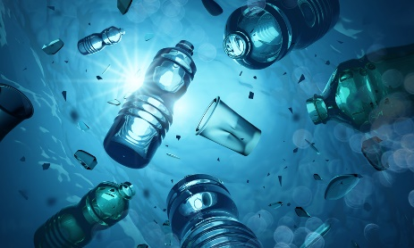 | See if you can make your own ocean by recycling a bottle. You will need to use some water, blue food colouring, pebbles and oil.  