Friday 10th July
The end of another week! I do hope you have all had a great week and have a super weekend. We have a birthday in our family (not mine!) this weekend, so I am excited!! I have some BIG news to tell you next week.

English
The lesson today is based on a book called, ‘Agents of the Wild’ by Jennifer Bell. I hope you enjoy hearing the clips and completing the tasks. https://www.bbc.co.uk/bitesize/articles/z2c2kty

Maths – Challenge Time

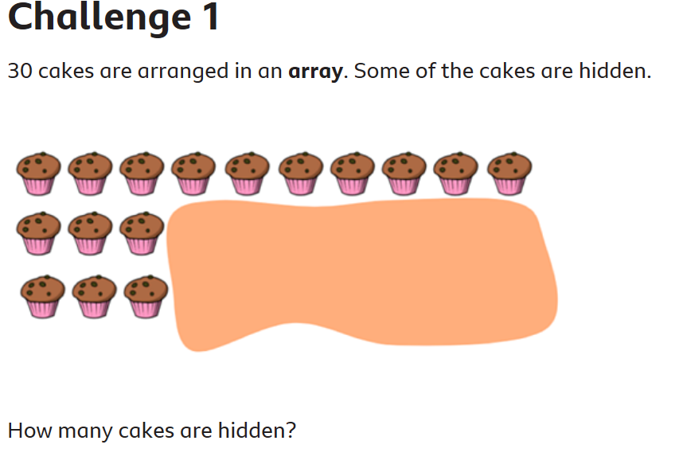 | 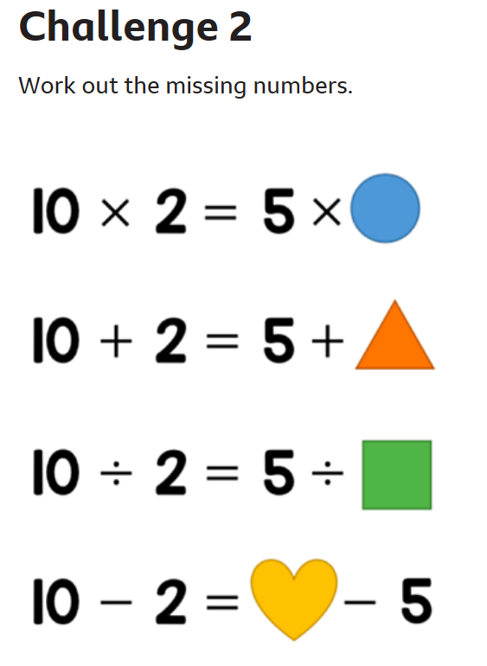
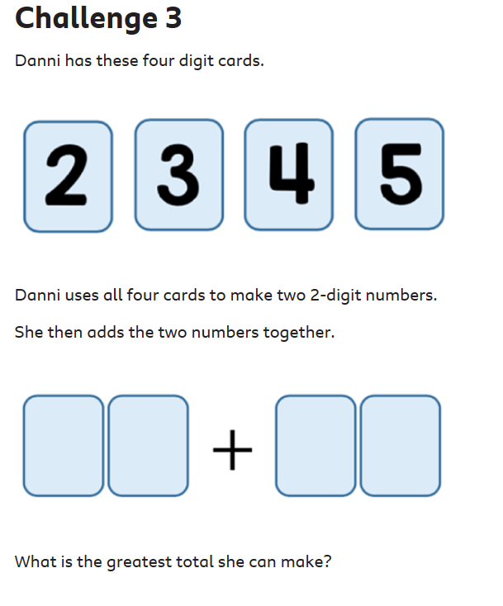 | 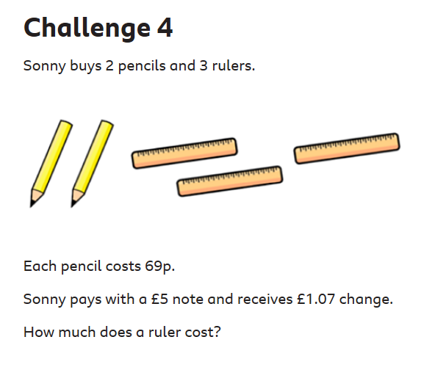

Well done
Mrs C Flynn

